QM Lab Course Project

User Manual

(As of March 20, 2016)

Group 3

Angela Stankowski (ans723), Bengin Lee (bel529), Connor Nettleton-Gooding (cwn973), Corey Hickson (crh208), Darvin Zhang (ddz369), James McKay (jlm012), Jordan Wong (jtw289), Mack Mahmoud (mtm464), Matt Hamilton (mch986), Michael Kelly (mlk121), Michael Ruffell (mar492), Mitchell Lau (chl929), Royce Meyer (brm979), Shane Williamsom (saw056)

# Introduction

QM Lab is a qualitative modelling tool with collaborative functionality. It was commissioned by Nathaniel Osgood and Geoff MacDonnell back in January, 2016. Our group was tasked to design an application which would serve as a qualitative and collaborative modelling platform for users to create diagrams of various systems.

The purpose of this document specifically is to give the user a guideline of the necessary steps required to interact with QM Lab and its features properly and effectively.

# Getting Started

Before you can access the QM Lab application, you must be on or have a Google Account. To learn how to set one up, please view this link: <https://support.google.com/accounts/answer/27441?source=gsearch&hl=en>

After setting up a Google Account, Open any web browser (Google Chrome, Mozilla Fire Fox, Internet Explorer) and input the Following link on the browser’s address bar (Figure 1): <https://cmpt371g3.usask.ca/demo/development/src/Main>



**Figure 1: Example using Google Chrome**

Press the ‘Enter Key’ and you should be led to main page of the QM Application. You will see a page that has a section which looks like Figure 2. To access the application, you must hit the Sign in button as depicted in Figure 2.



**Figure 2: QM Lab webpage authorization**

If you aren’t already logged into your Google Account, you will be prompted to do so. After logging in, if it is your first time using QM-Lab, you will be given a message which authorizes the use of QM-Lab (Figure 3). Click the ‘Allow’ button to use the application.

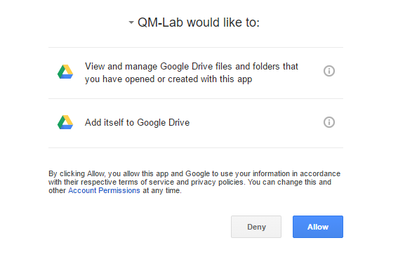.

**Figure 3: QM-Lab authorization prompt**

You should now see the main page of the application. If you have already allowed the access of QM-Lab previously, you should already be at the main page.

As of this time, the main simply allows to name and create a file (Selecting and deleting projects are not yet implemented). After entering a name and clicking ‘create’. An example of this is shown in Figure 4.

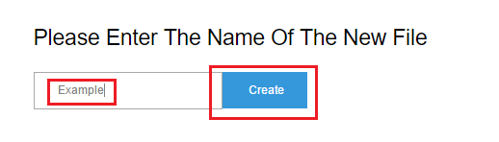

**Figure 4: Main page file creation example in QM Lab**

After creating an file you will be sent to the editing page of the file. The page consists of four main the sections. The operations bar at the top left corner of the page, the nodes/links toolbar at the left hand side, the properties options just below the toolbar, and the large collaborative paper, in the border, and encompassing most of the screen. Figure 5/6 display the page and both the options that the nodes and links have.

**Figure 5: QM Lab Collaborative Application (Nodes side)**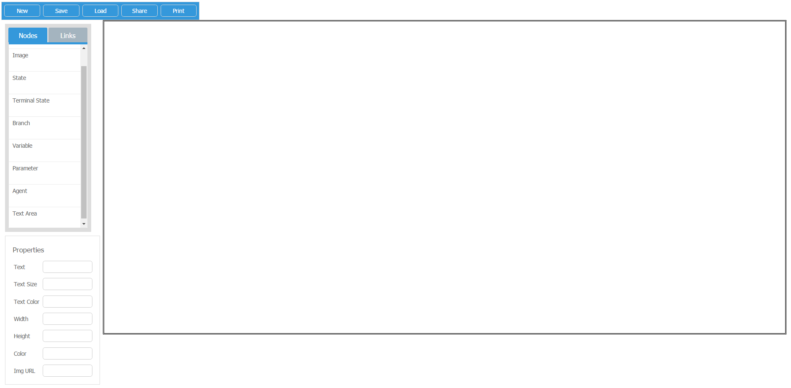

**Figure 6: QM Lab Collaborative Application (Links side)**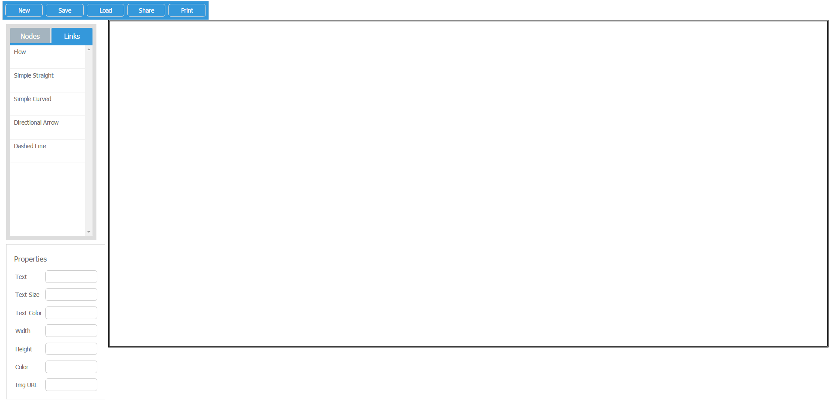

# Tool Explanation

This section provides a detailed explanation of each of the sections in Figures 5/6 and their features. It will also expand upon other elements of the application (such as the home page when implemented fully). This section has not yet been expanded upon.

# Using The System

This section provides a description of the various functions of the system and how to use them. Expanding on the Tools explanation and how to use them with one another.

**Adding a Node and Link to the project:**

The following steps can be taken for adding a Node and a link to a project:

* Select Node or Link in the toolbar they are in (depending on which one you want)
* Click on type of Node or Link
* Click on the collaborative paper section of the project you want to add the object to

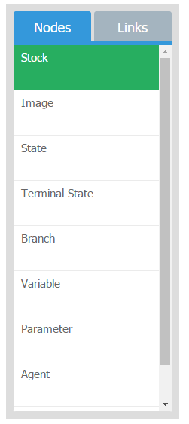

**Figure 7: Selecting a Node example**

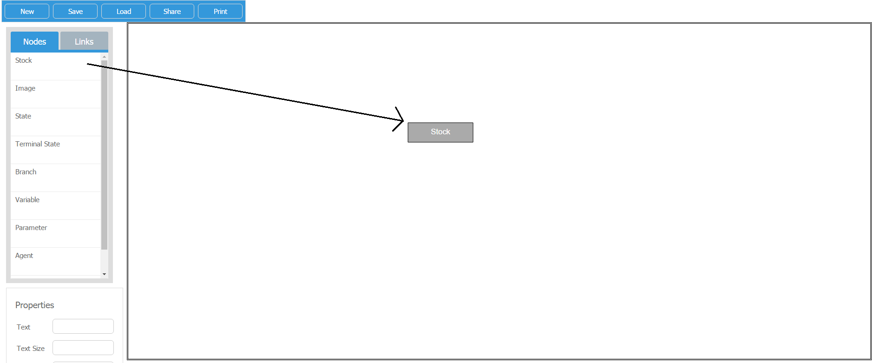

**Figure 8: Example of clicking an area of the paper to add the Node selected**

**Deleting a Node/Link:**

The following steps can be taken for deleting a Node or a Link from the project”

* Click on a Node or a Link
* Press the ‘Delete’ key on your keyboard (For Links one may also hit the red x when selecting them)

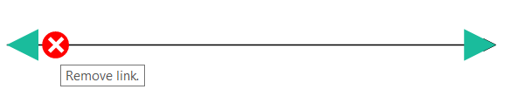

**Figure 9: The Red x for deleting a Link**

**Linking a Node:**

The following steps can be taken for linking a Node:

* Select a Link object on the collaborative paper
* Click one end of the Link and drag it on top of a Node object, so simply drag the entire Link end over the Node.

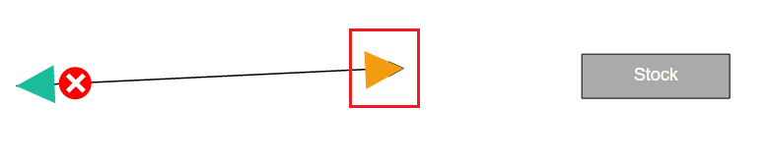

**Figure 10: Selecting a End of a Link**

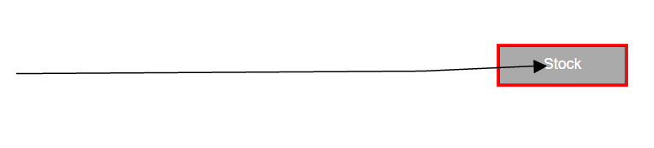

**Figure 11: Dragging the end of a Link into a Node**

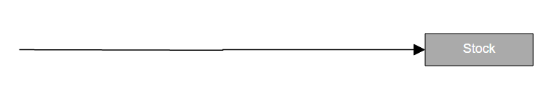

**Figure 12: Sample of a finished connection**

**Changing/Adding text to a Node/Link:**

The following steps can be taken for editing the text of a node/link:

* Click on an existing Node/Link or create one
* Go to the properties section of the webpage and find the text section
* Click inside of the field and edit the text
* Press the ‘Enter’ Key to save

**Changing the size of a Node:**

The following steps can be taken for changing the size of a node:

* Click on an existing Node or create one
* Go to the properties section of the webpage and find length and width sections
* Click inside of the field of choice and edit it (with a proper integer)
* Press the ‘Enter’ Key to save

**Changing the color of the text/skin of a Node/Link:**

The following steps can be taken for changing the color of a node/Link:

* Click on an existing Node/Link or create one
* Go to the properties section of the webpage and find text color or color
* Click inside the field and you should be given an array box of colors
* Click on the color you wish

**Figure 12: Example of changing the color of a Node**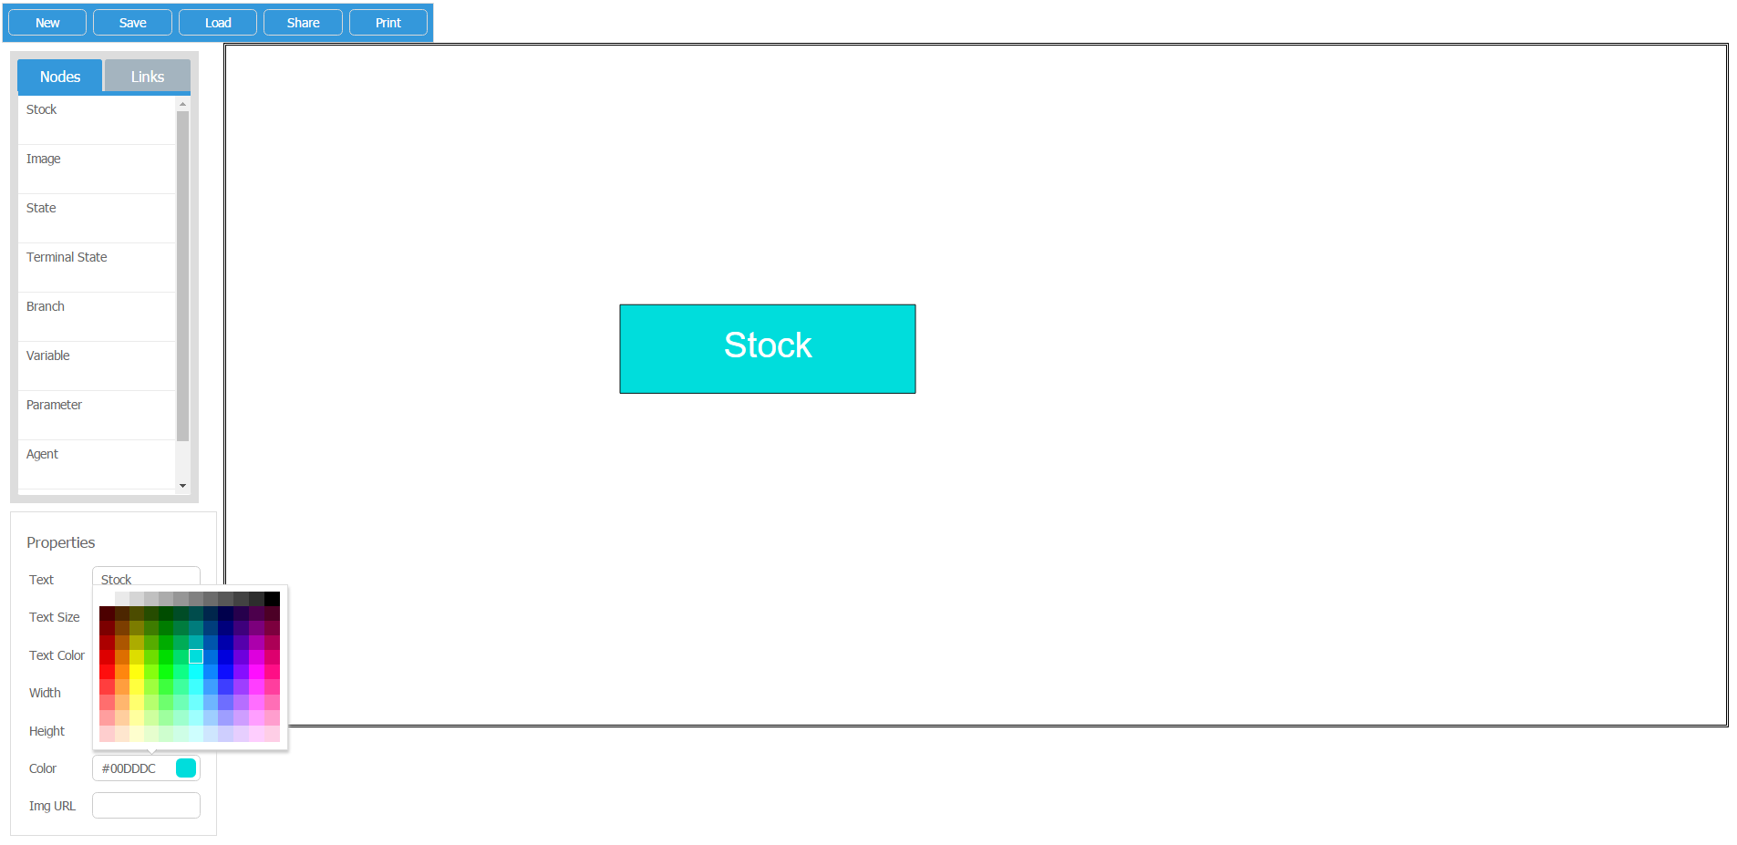

**Adding an Image (Through URL):**

The following steps can be for adding an image to the project:

* Click on an select and add the Node with the tag “Image” in the toolbar
* Go to the properties section of the webpage and find the URL section
* Click inside of the field of choice and proper URL of the image you wish to add
* Press the ‘Enter’ Key to save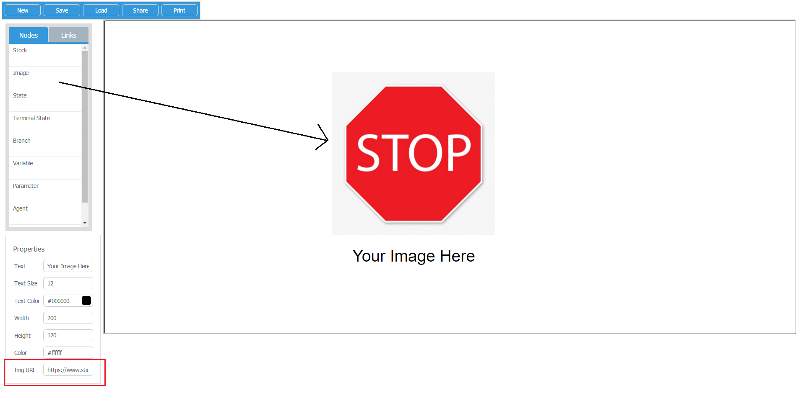

**Figure 13: Example of adding an Image to QM-Lab**

**Editing and changing the form of a Link:**

The following steps can be taken for morphing a Link:

* Click on an existing Link or create one
* Hover over the Link, it contains circles and two arrows at each end
  + The circles allow you to bend the Link in the direction you drag and hold the circle towards.
  + You may add more bending points (The kind of bend depends on your selected Link type) if you click on any area of a Link
  + The bending point may also be deleted if you hover over the point and click the white x in the black word cloud
* Click on the arrows and drag them to change the length of the Links or click on the circles and drag them to bend the Link



**Figure 14: Hovering over a Link**

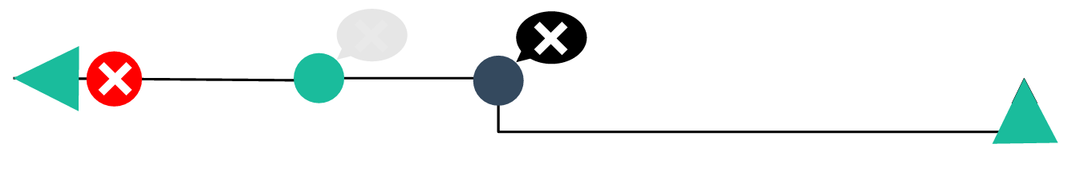

**Figure 15: Example of Bending Points added, a bent link, and selecting a bending point**

**Zooming in and out and moving within the collaborative paper:**

The following steps can be taken for zooming and moving the collaborative paper.

* To move the paper to around, simply right-click on an area of the paper that does not have an object currently on it and drag your mouse to the opposite direction of where you want to move to.
* To zoom in and out of a section of the paper, you currently must have to have a touchpad. Since touchpads are different, please find out how yours zooms and out. Then pick an area that you wish to zoom in/out and perform the action.